**Lifechoices (Practical)**

**NQF LEVEL 3**

**2020**

**09:00 – 13:00**

**TIME: 4 HOURS**

**MARKS: 100**

_____________________________________________________________________

**INSTRUCTIONS AND INFORMATION**

1. Answer ALL the questions.
2. Read ALL the questions carefully.
3. Number the answers according to the numbering system used in this question

paper.

**Challenge 2 : BMI Calculator**

The management at the gym you go to asked you to design an application that will calculate the *Body Mass Index (BMI)* of gym members. They want to distribute the program to gym members so that they can easily calculate their own *BMI*.

The following table is a summary of the different BMI weight status:

|  |  |
| --- | --- |
| **BODY MASS INDEX** | **WEIGHT STATUS** |
| BMI < 18 | Underweight |
| BMI >= 18 and < 25 | Normal |
| BMI >= 25 and < 30 | Overweight |
| BMI >= 30 | Obese |

*BMI* can unfortunately wrongly suggest fatness in people. Therefore apart from the standard *BMI* calculation you can also calculate what is referred to as the *Ideal Body*

*Mass Index*. This formula also takes your *Gender* into consideration (*Male* or *Female)*

and if you are *Female*, it also considers your *Age* before calculating what is referred as

the *“Peoples Choice” Ideal BMI*.

The program you are going to design will need the *Weight* and *Height* of a gym

member to calculate their *normal BMI*. To calculate the *Ideal BMI* of a gym member

the program also needs to know if the gym member is a *Male* or *Female* and if *Female*,

their *Age*.

The IPO-chart for the problem is as follows:

|  |  |  |
| --- | --- | --- |
| **INPUT** | **PROCESSING** | **OUTPUT** |
| Weight (in kg)  Height (in cm)  Gender  Age | BMI  = Weight / (Height / 100) ^ 2  Ideal BMI (Males)  = 0.5 * Weight / (Height / 100) ^ 2 + 11.5  Ideal BMI (Females)  = 0.5 * Weight / (Height / 100) ^ 2 + 0.03 * Age + 11 | BMI  Ideal BMI |

FIGURE 1 below is a print screen of what the user interface looks like. The completed interface has been saved on the hard disk. Open the solution **BodyMassIndex** and

follow the instructions to complete the program:

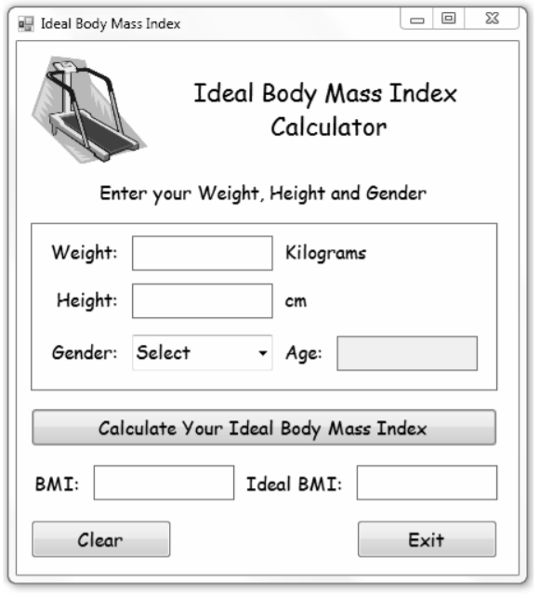

FIGURE 1

The following STEPS explain how to use the Body Mass Index Calculator program to calculate the *BMI* and *Ideal BMI* of a gym member:

STEP 1 RUN the program and enter the *Weight* and *Height* of a gym member.

Select the *Gender* and if *Female* enter the *Age*.

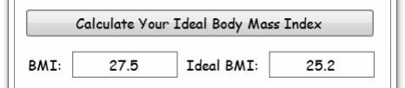

STEP 2 Click on the *Calculate Button* to display the *BMI* and *Ideal BMI* labels.

TASK

1.1 Add your name and surname as comments to the program source code. Use tkinter to design an interface like the one above. You are free to deviate a bit to make your interface design look nice. (10)

1.2 When the *Form* loads:

1.2.1 The *Combo Box* must display the first item in the list. (1)

1.2.2 Disable the *Age Text Box*. (1)

1.3 When the content displayed in the *Combo Box* changes:

1.3.1 Clear the contents of the *Age Text Box*. (1)

1.3.2 If *Female* is selected enable the *Age Text Box* and move the cursor

(focus) to the *Age Text Box.* If *Female* is NOT selected disable *the*

*Age Text Box*. (3)

1.4 Create a *User Defined Function (CalcBMI)* which will receive the *Weight* and

*Height* of a gym member and return the calculated *BMI* to the calling *event procedure*. (5)

1.5 Create a *User Defined Function (CalcIdealBMI)* which will receive the *Weight*,

*Height* and *Age* of a gym member and return the calculated *IdealBMI* to the

calling *event procedure*. The *Function* must use the correct formula to calculate the *IdealBMI* for *Males* or for *Females*. (9)

1.6 When the user clicks on the *Calculate Button,* the program should:

1.6.1 Check for *numeric* values in ALL the *Text Boxes* and make sure

that a *Gender* has been selected. If NOT, the program must alert

the user, terminate the calculation and move the cursor (focus) to

the appropriate *Control* on the *Form*.

1.6.2 Call the *User Defined Functions* to calculate the *BMI* and *IdealBMI*.

1.6.3 Display the *BMI* and *IdealBMI* in the labels on the form formatted to

ONE decimal place e.g. 25.2. (21)

1.7 When the user clicks on the *Clear Button,* the program should:

Clear ALL the *Controls* on the *Form*, select the first item in the *Combo Box*

and move the cursor to the *Weight Text Box*. (4)

1.8 When the user clicks on the *Exit Button*, the application should close. (1)

1.9 Make a printout of the source code. (1)

1.10 Change the text in the title bar of the *Form* (Ideal Body Mass Index) to your

Name and surname.

1.10.1 Run the program, enter the following test data and print the form:

Weight: 77, Height: 179, Gender: Male (1)

1.10.2 Run the program, enter the following test data and print the form:

Weight: 65, Height: 156, Gender: Female, Age: 44 (1)

**[60]**